

American International University-Bangladesh (AIUB)

Faculty of Science and Technology

Design and Development of an E-Learning Platform for Life Skills Education

Tamanna E Fatema Hridi (18-36861-1)

Syed Masavi (20-42703-1)

A Software Project submitted for the degree of Bachelor of Science (BSc) in   
Computer Science and Engineering (CSE) at   
American International University Bangladesh (AIUB)  
Faculty of Science and Technology (FST)

Spring 2024-2025 Semester

Submission Date: Month, Year

# Declaration

This project is composed of our original work, and contains no material previously published or written by another person except where due reference has been made in the text. We have clearly stated the contribution of others to our project as a whole, including statistical assistance, survey design, data analysis, significant technical procedures, professional editorial advice, financial and any other original research work used or reported in our project. The content of our project is the result of work we have carried out since the commencement of the Software Project.

We acknowledge that copyright of all material contained in my project resides with the copyright holder(s) of that material. Where appropriate we have obtained copyright permission from the copyright holder to reproduce material in this project and have sought permission from co-authors for any jointly authored works included in the project.



|  |  |
| --- | --- |
| _______________________________  **Syed Masavi**  20-42703-1  Department | _______________________________  **Tamanna E Fatema Hridi**  18-36861-1  Department |
|  |  |
|  |  |

# Approval

The project titled **“Design and Development of an E-Learning Platform for Life Skills Education”** has been submitted to the following respected members of the board of examiners of the department of computer science in partial fulfilment of the requirements for the degree of Bachelor of Science in Computer Science on **(date of defense)** and has been accepted as satisfactory.

|  |  |  |  |  |
| --- | --- | --- | --- | --- |
| **Abhijit Bhoumik**  Associate Professor & Supervisor  Department of Computer Science  American International University-Bangladesh | |  | **Nyme Ahmed**  Lecturer & External  Department of Computer Science  American International University-Bangladesh | |
|  | | | | |
|  | **Dr. Debajyoti Karmaker** Associate Professor & Head (UG) Department of Computer Science American International University-Bangladesh | | |  |
| **Prof. Dr. Dip Nandi**  Professor & Associate Dean  Faculty of Science and Technology  American International University-Bangladesh | |  | **Mashiour Rahman**  Sr. Associate Professor & Dean  Faculty of Science and Technology  American International University-Bangladesh | |

# Acknowledgement

Acknowledgements recognize those who have been instrumental in the completion of the project. Acknowledgements should include any professional editorial advice received including the name of the editor and a brief description of the service rendered.

# Author Contributions

List the significant and substantial inputs made by different authors to this project work and writing represented and/or reported in the software project. These could include significant contributions to the conception and design of the project; non-routine technical work; analysis and interpretation of project work; drafting significant parts of the work or critically revising it to contribute to the interpretation.

|  |  |  |  |  |
| --- | --- | --- | --- | --- |
|  | **Syed Masavi** | **Tamanna E Fatema Hridi** | **Comments** | |
|  | *20-42703-1* | *18-36861-1* |
| **0 - 3 points** | **Perform as effective individual** | | | | |
| Critical thinking |  |  |  |  |  |
| Reflection on feedback |  |  |  |  |  |
| Quality of work |  |  |  |  |  |
| Self-directed |  |  |  |  |  |
| **0 - 3 points** | **Perform as effective team member/leader** | | | | |
| Taking responsibility |  |  |  |  |  |
| Contribution |  |  |  |  |  |
| Collaboration |  |  |  |  |  |
| Working with others |  |  |  |  |  |
| **0 - 3 points** | **Perform as effective team member/leader** | | | | |
| Presentation delivery |  |  |  |  |  |
| Voice and tone |  |  |  |  |  |
| Enthusiasm |  |  |  |  |  |
| Creativity & Tools use |  |  |  |  |  |

# Project Planning

* Identify all the micro tasks related to project management and categorize them within the Work breakdown structure (WBS) of your project work. And describe the available resources and their allocation.

Table 3: Project Deliverables

|  |  |  |
| --- | --- | --- |
| **Project Tasks** | **Schedule Data** | **Execution Data** |
| 1. Planning | 28-Apr-25 | 4-May-25 |
| 1. Literature Review | 5-May-25 | 17-May-25 |
| 1. System Design | 18-May-25 | 7-Jun-25 |
| 1. Implementation | 8-Jun-25 | 22-Jun-25 |
| 1. Progress Review | 23-Jun-25 | 29-Jun-25 |
| 1. Software Project Writing | 30-Jun-25 | 11-Jul-25 |
| 1. Submission and Review | 13-Jul-25 | 06-Aug-25 |

# Table of Content

Contents

Declaration ii

Approval iii

Acknowledgement iv

Author Contributions v

Project Planning vi

Table of Content vii

List of Figures viii

List of Tables ix

List of Abbreviations x

Abstract xi

Keywords xi

Chapter 1 12

Introduction 12

1.1 Background Analys 12

1.2 Existing Studies 12

1.3 Research Motivation and Objective 12

1.4 Research Contribution 13

Chapter 2 14

Research Methodology 14

2.1 Conceptual Framework 14

2.2 Data Collection 14

2.3 Ethical Issues 15

2.4 Economic Decision 15

Chapter 3 16

Results and Analysis 16

3.1 Results and Analysis 16

3.2 Accuracy and Verification 16

3.3 Impact Analysis 16

Conclusion 17

References 18

Appendix 19

# List of Figures

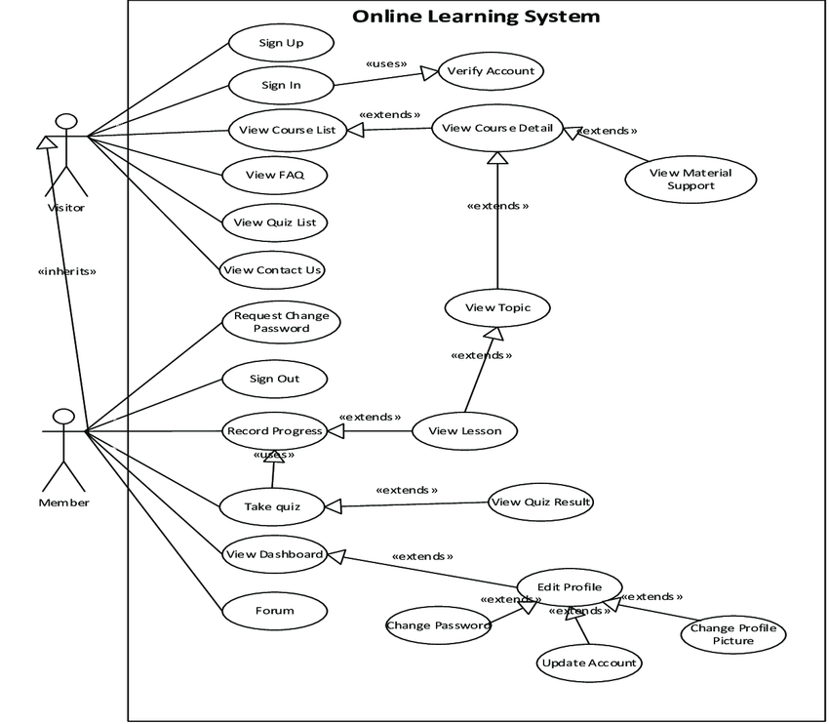

Figure 1 : Use Case Diagram

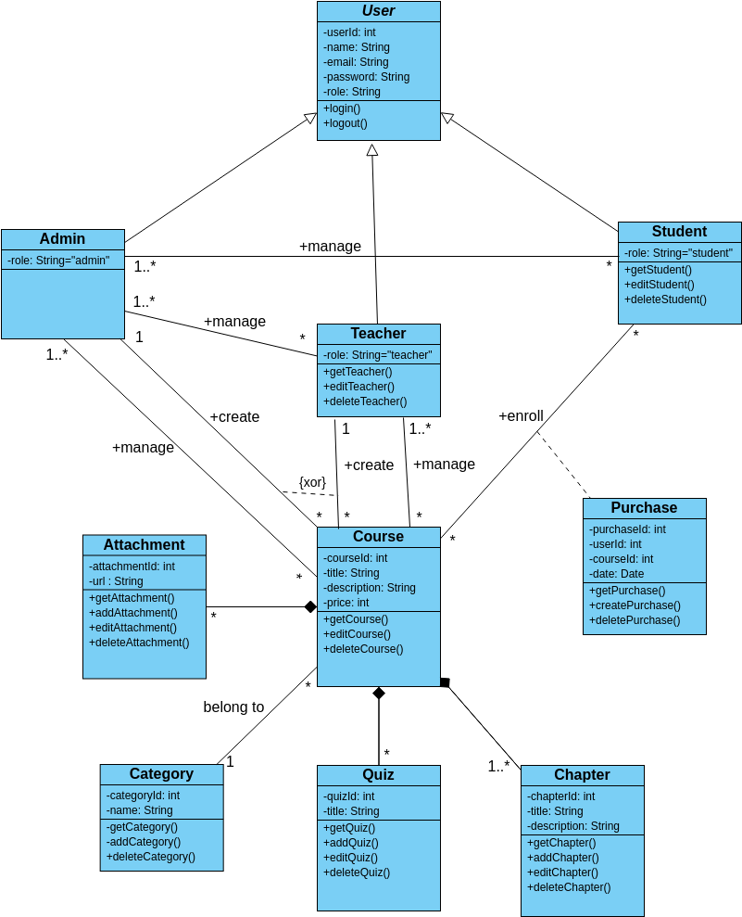

Figure 2 : Class Diagram

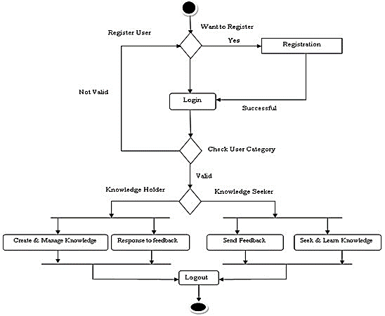

Figure 3 : Activity Diagram

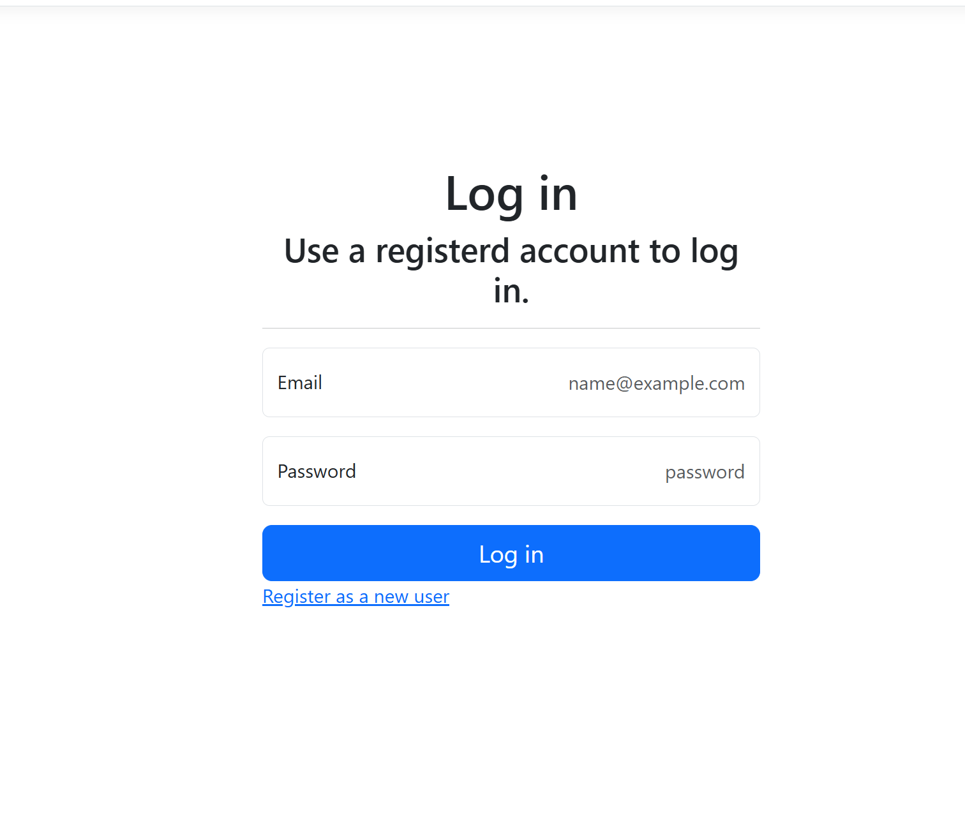

Figure 4: Student Login Page

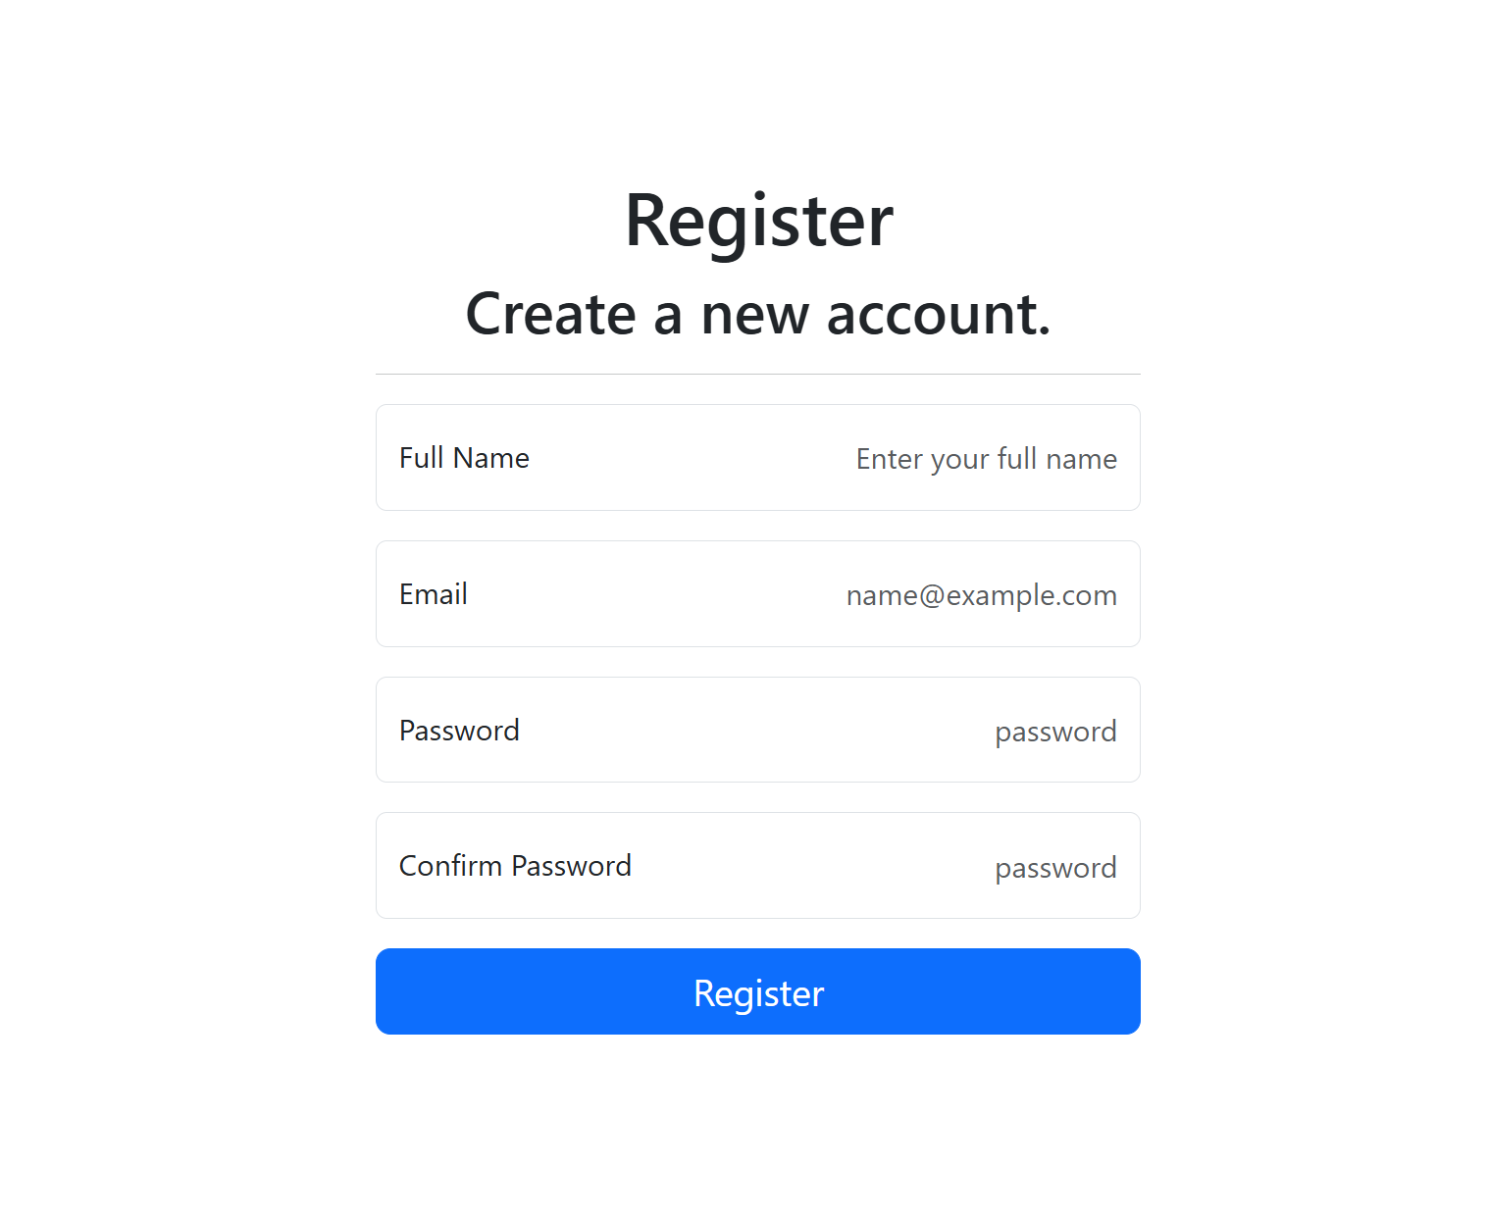  
Figure 5: Student Registration Page

  
Figure 6: Admin Dashboard – Course Overview

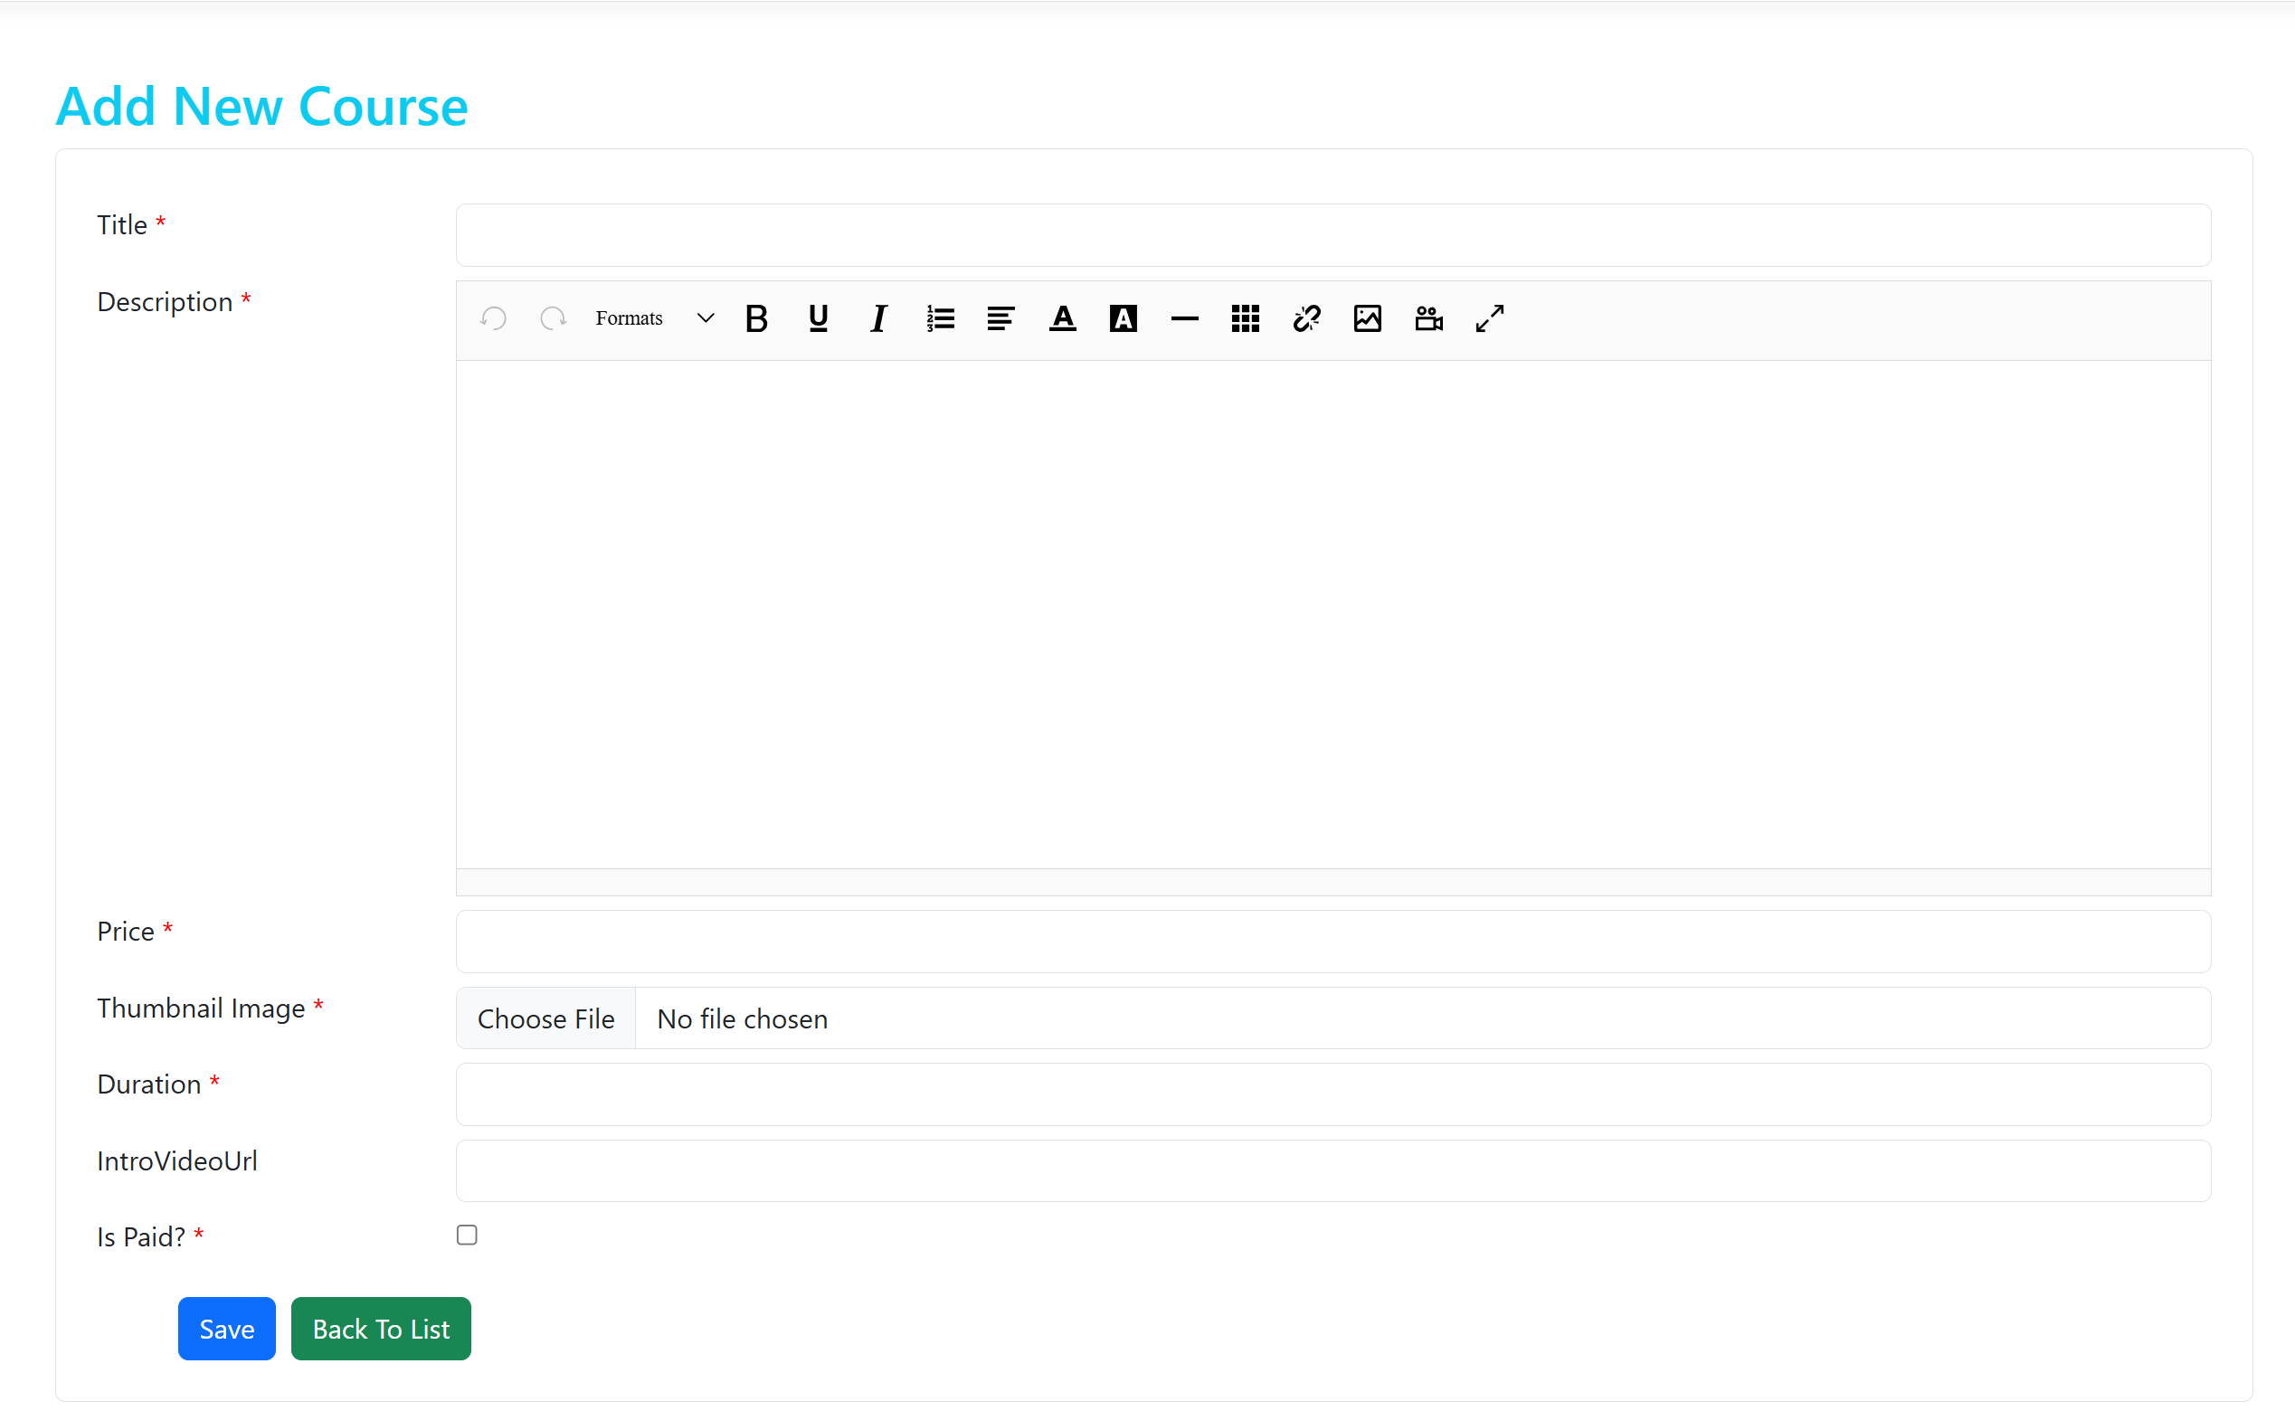  
Figure 7: Create New Course Form (Admin)

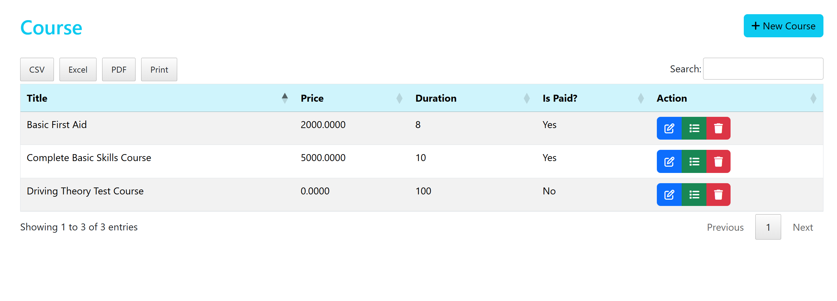  
Figure 8: Edit and Manage Existing Courses (Admin)

  
Figure 9: Course Enrollment Page

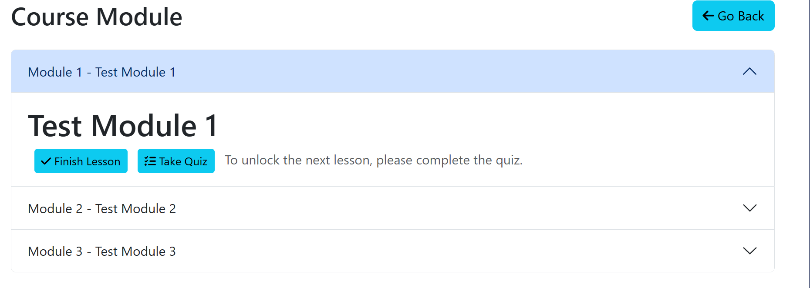  
Figure 10: Learning Module View – Text, Video, and Image Content

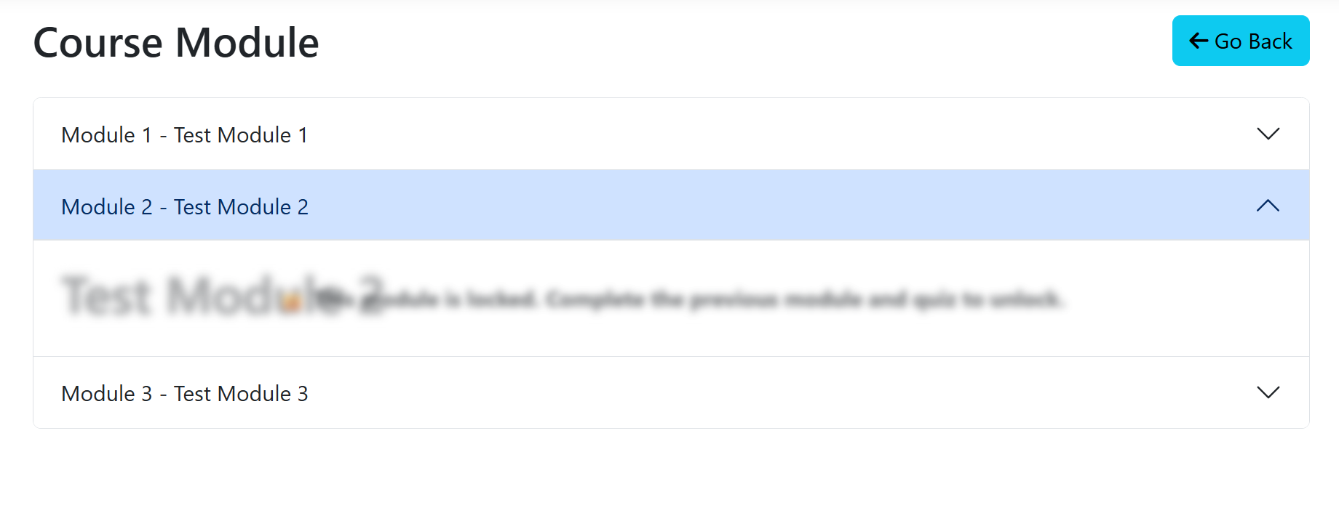Figure 11: Sequential Learning Progress – Locked and Unlocked Modules

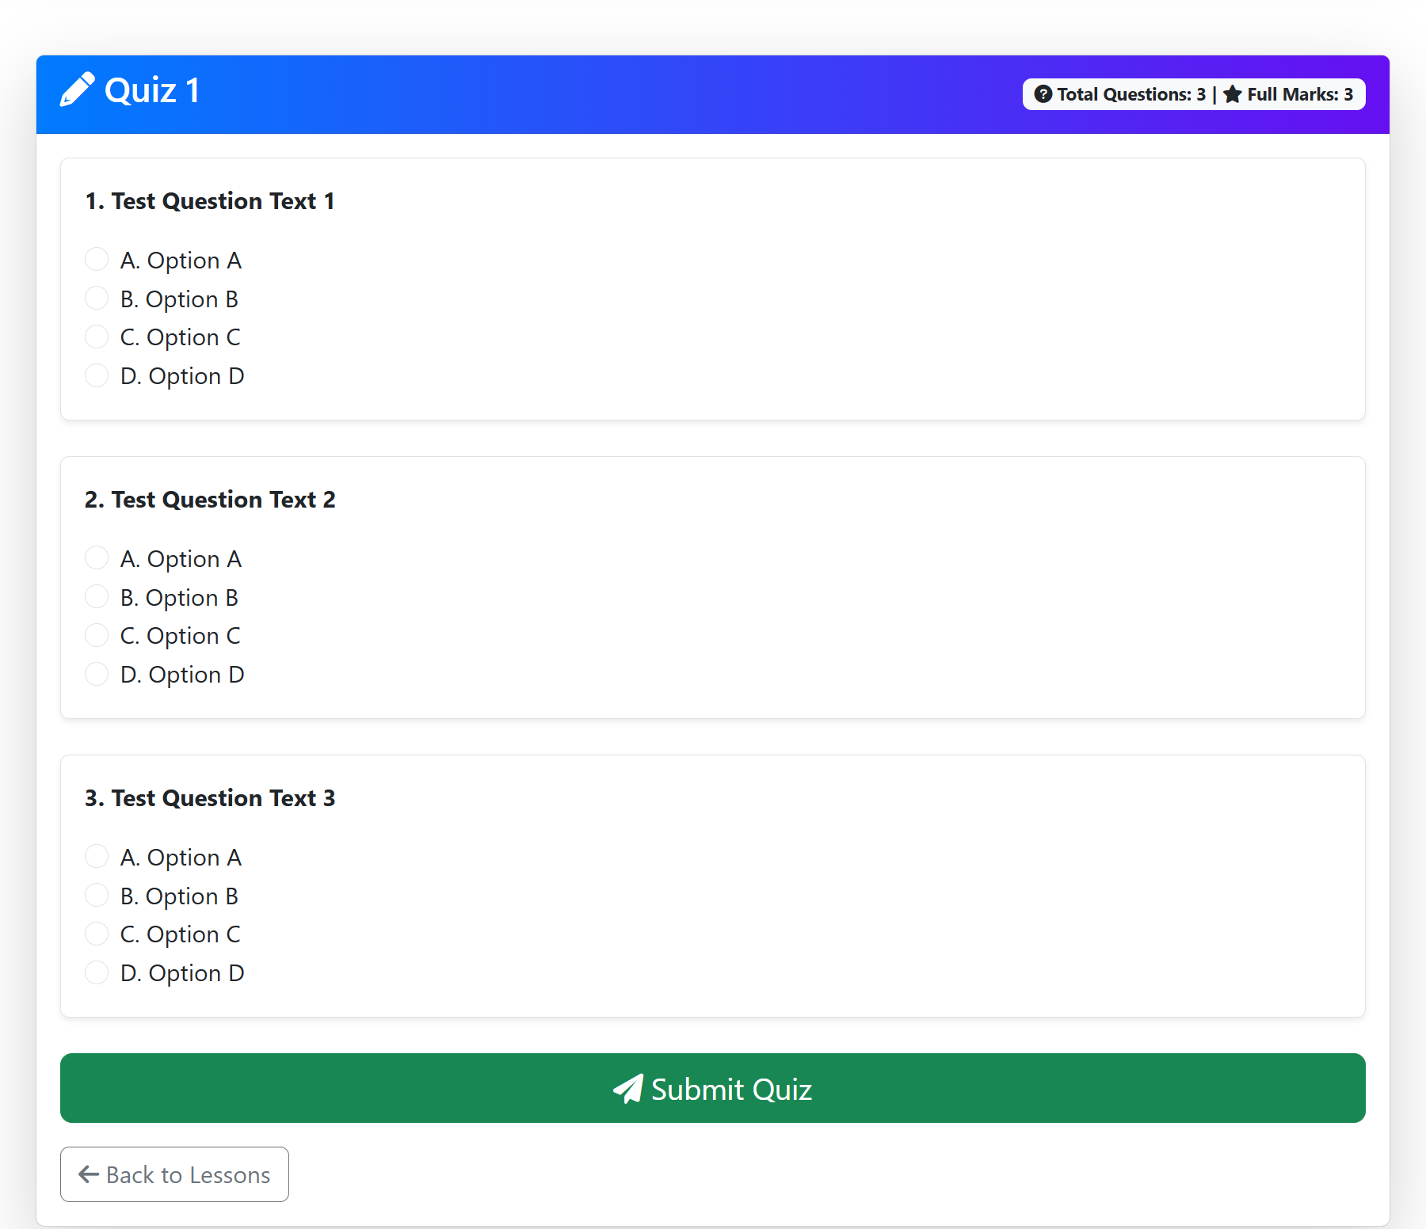  
Figure 12: Quiz Attempt Page (MCQ Questions)

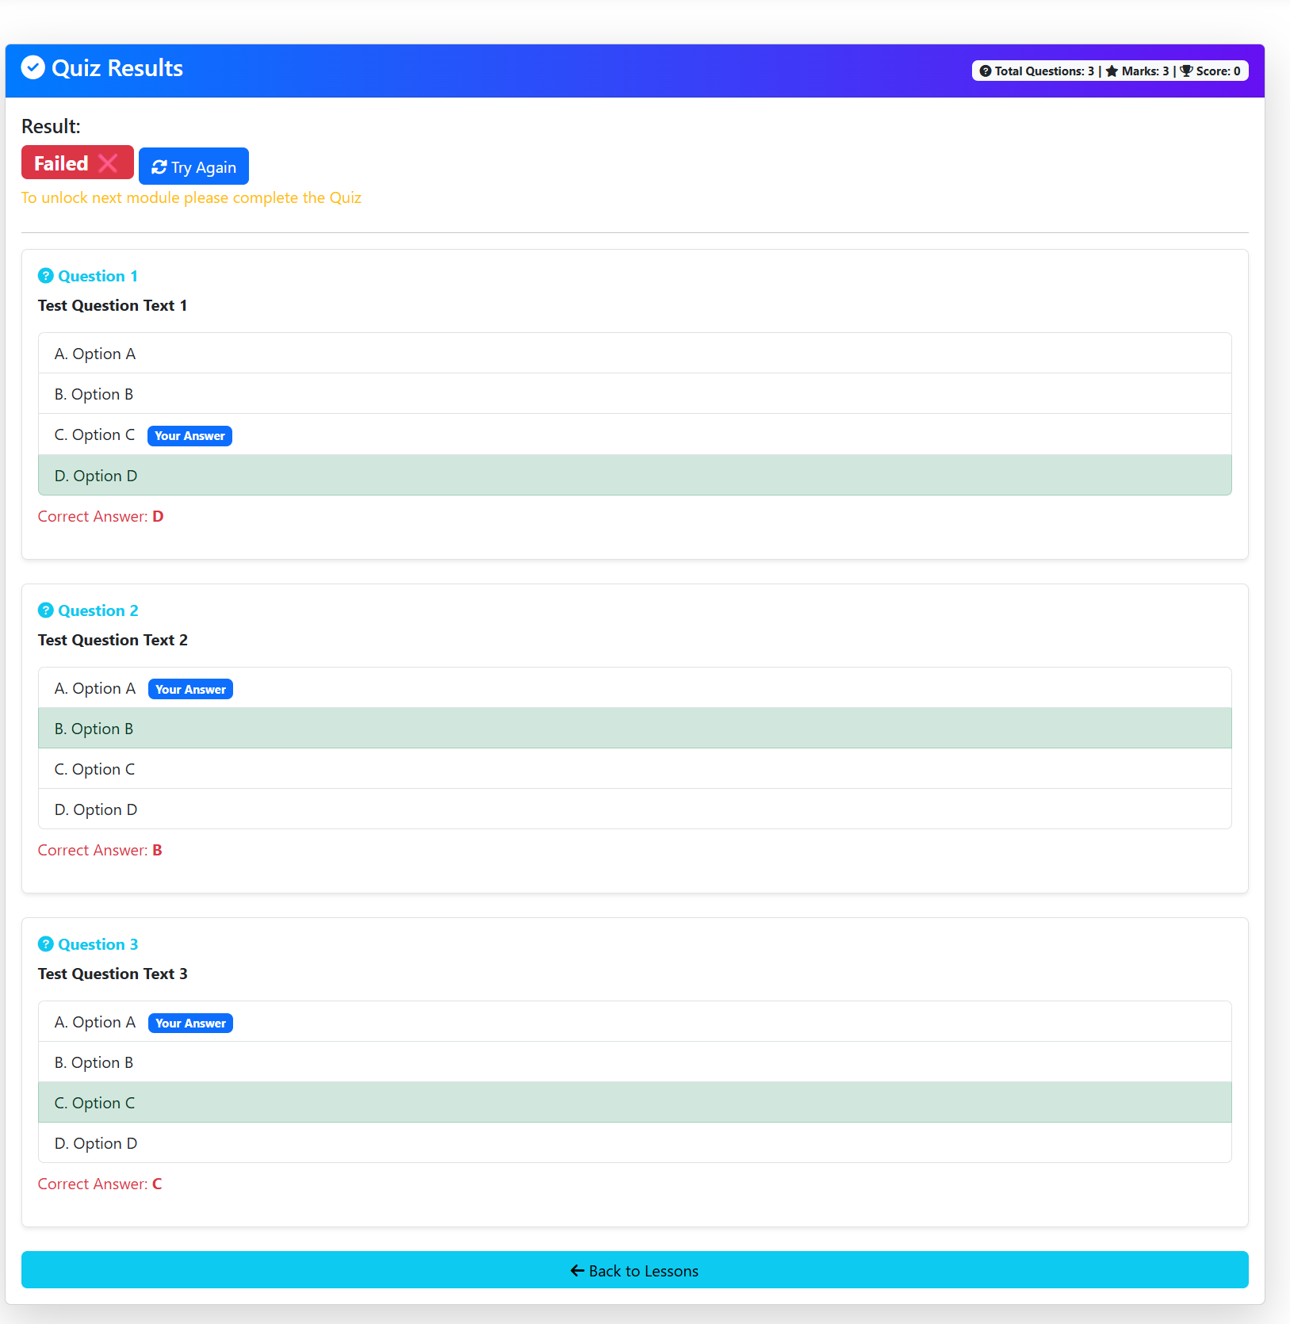  
Figure 13: Quiz Results – Auto-marked Feedback

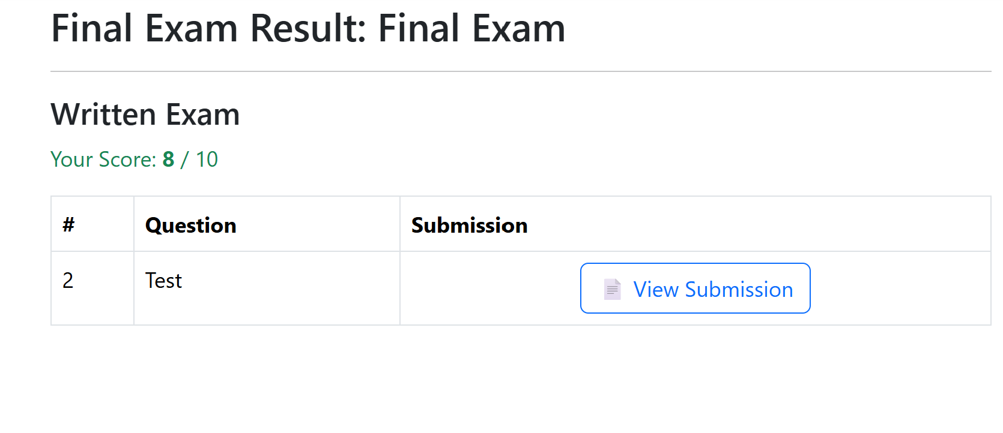  
Figure 14: Final Exam Result

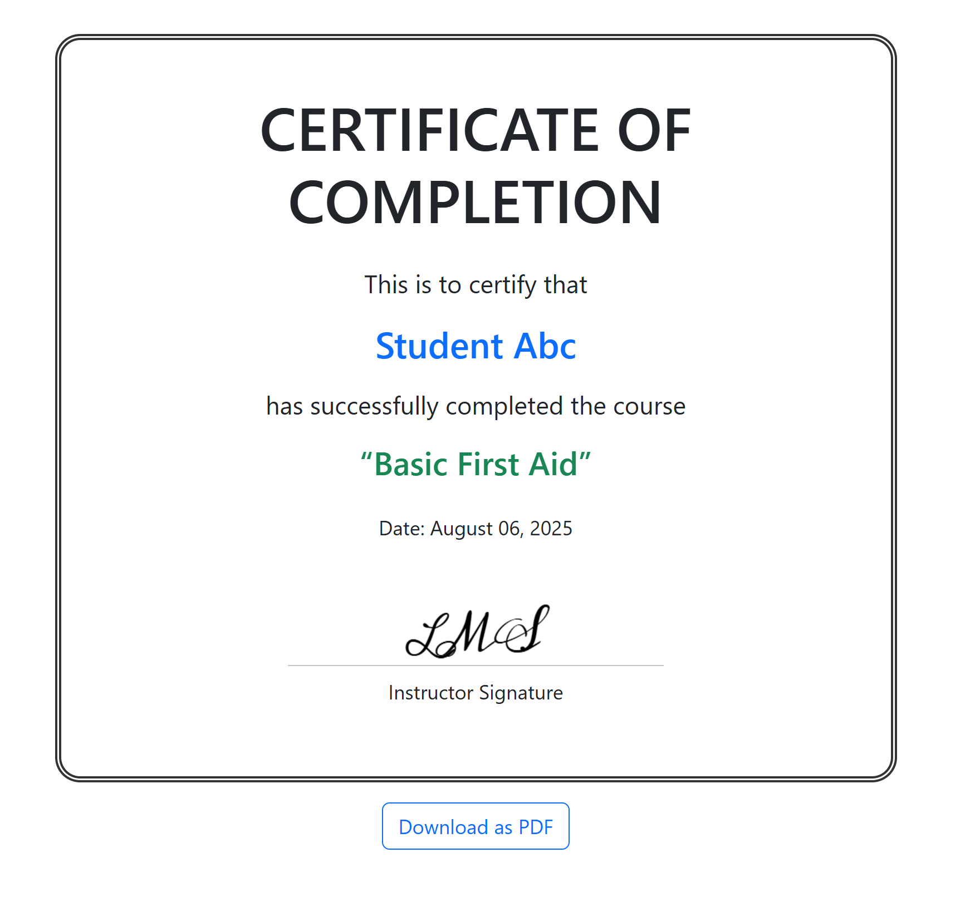

Figure 15: Generated PDF Certificate – Auto-filled Student Details

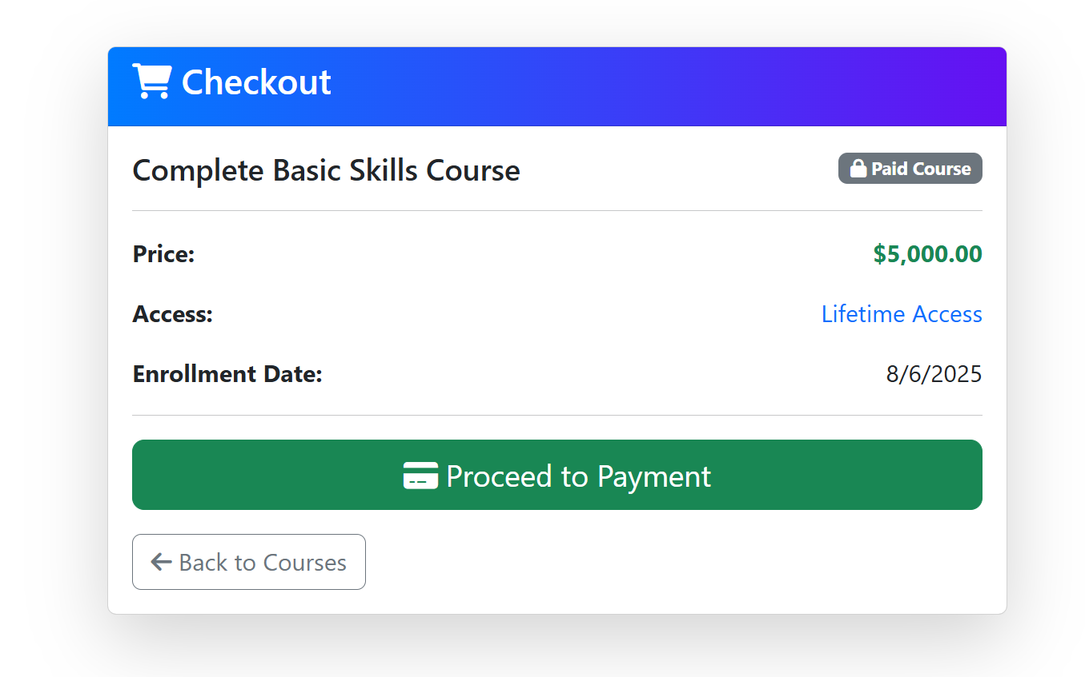  
Figure 18: Payment Gateway Checkout Page

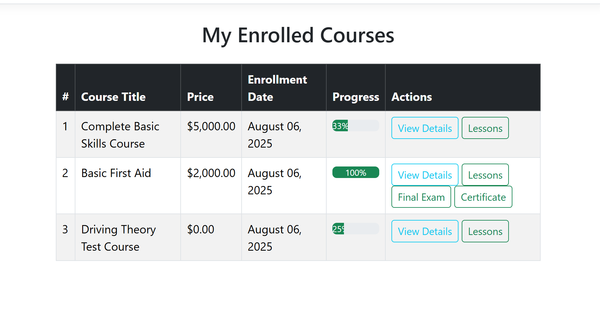  
Figure 16: Student Dashboard – Enrolled Courses & Progress

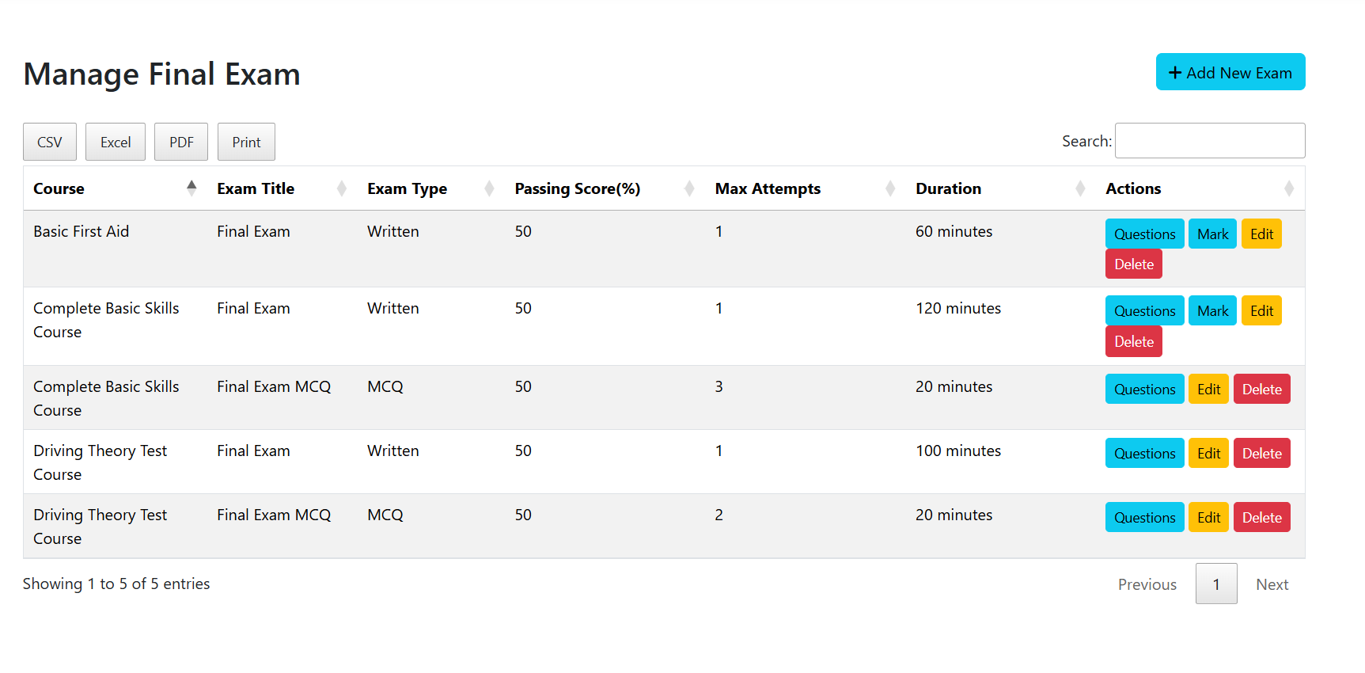  
Figure 17 :Admin Dashboard –Final Exam Manage

# List of Tables

|  |  |  |
| --- | --- | --- |
| Table 1: | List of data | 18 |
|  |  |  |

# List of Abbreviations

Mention all the abbreviations and the different symbols that are used in this document.

Example:

|  |  |
| --- | --- |
| CS | Computer Science |
| CSE | Computer Science and Engineering |
| HCI | Human Computer Interaction |
| NLP | Natural Language Processing |

# Abstract

This project presents the design and implementation of a role-based Learning Management System (LMS) tailored for educational institutions to manage online courses, assessments, and student progress efficiently. The system allows three primary user roles: Admin, Instructor, and Student. Admins manage course content, exams, and user roles; instructors can create modules, quizzes, and final exams; students enroll in courses, complete lessons, and attempt assessments.

The LMS was developed using ASP.NET Core MVC with Entity Framework for data management and SQL Server as the backend database. Identity authentication and authorization were implemented to provide secure login, role-based access control, and personalized user experiences. Key modules include course and module management, quiz and final exam handling (MCQ and written formats), progress tracking per module, and dynamic certificate generation for students who complete and pass all required exams.

The need for such a system arises from the growing demand for digital learning platforms that support remote education and continuous assessment. This system facilitates structured learning, timely feedback through automated quiz scoring and manual written exam marking, and transparent tracking of student progress.

Results demonstrate the LMS’s effectiveness in managing course enrollments, delivering learning content, conducting both objective and subjective assessments, and generating accurate performance reports and certificates. The platform also includes administrative features like attempt limits, real-time performance evaluation, and student-specific exam feedback.

The significance of this project lies in its ability to automate and streamline academic workflows, reduce manual intervention, and enhance the overall learning experience. It provides a scalable foundation for institutions looking to adopt or improve their digital education infrastructure.

# Keywords

learning management system, asp.net core, role-based access, student progress, online courses, quiz, final exam, certificate, written exam, education platform

# Chapter 1

# Introduction

In the digital age, Learning Management Systems (LMS) have become essential tools for delivering structured and interactive education. The demand for online education platforms has grown significantly, particularly due to the shift toward remote learning models. However, many existing systems lack the flexibility, role-based control, and integrated evaluation features necessary to fully support modern academic workflows.

This project proposes a role-based LMS developed using ASP.NET Core MVC that supports administrators, instructors, and students. It includes essential features such as course management, modular lesson tracking, interactive quizzes, manually marked final exams, and certificate generation. A key innovation is the conditional unlocking of modules based on quiz performance, promoting structured learning progression.

By integrating automated assessments with manual evaluation and real-time progress tracking, this LMS offers a complete solution for institutions aiming to digitize their teaching and evaluation processes. The system is designed to be scalable, secure, and user-friendly, bridging the gap between traditional learning methods and modern e-education requirements.

# **Background Analys**

The integration of technology in education has become increasingly vital, particularly with the rise of online and hybrid learning models following global events such as the COVID-19 pandemic. According to UNESCO, over 1.6 billion learners were affected globally by school closures, which accelerated the adoption of digital platforms in education. Institutions now face the challenge of delivering structured, engaging, and accessible learning experiences to students regardless of geographical barriers.

Despite this shift, many educational platforms lack core functionalities like automated assessment, student progress tracking, and role-based content delivery. In traditional classroom settings, educators manually monitor student progress, evaluate performance, and maintain administrative records—processes that become inefficient and error-prone when scaled online.

A critical root cause of this issue lies in the absence of centralized, customizable systems that cater to diverse educational roles such as administrators, instructors, and students. Current solutions are often either too rigid or overly complex for mid-sized institutions or universities.

This thesis addresses these limitations by developing a robust, role-based Learning Management System (LMS) that streamlines course delivery, student evaluation, and certificate generation, tailored for modern educational needs.

# **Existing Studies**

A considerable body of research and development has been dedicated to LMS platforms, including Moodle, Blackboard, and Google Classroom. These systems offer comprehensive features but often lack customization for localized institutions and smaller-scale institutions with unique needs.

Several studies (e.g., Al-Samarraie et al., 2020; Liaw et al., 2007) highlight usability challenges, integration issues, and high learning curves as persistent gaps in existing LMS solutions. While many platforms support quizzes or online tests, few integrate manual written exam evaluation, tracking by module completion, or condition-based unlocking of lessons (e.g., pass a quiz to unlock the next lesson).

This project addresses the gap by implementing a lightweight, customizable LMS that balances automation with manual oversight—allowing written exam grading, module locking based on quiz performance, and final certificate generation only upon successful completion of all requirements.

# **Research Motivation and Objective**

* ***General aims*** – To design and implement a user-centric Learning Management System that enables educational institutions to manage, deliver, and evaluate online learning more effectively.
* ***Specific objectives*** –

1. To implement role-based access control for administrators, instructors, and students.
2. To allow course enrollment, modular lesson tracking, and conditional progression.
3. To design auto-marked quizzes and manually evaluated final written exams.
4. To generate completion certificates upon fulfilling all learning criteria.
5. To track student performance in real-time using progress dashboards.

* ***List your research questions*** –

1. RQ1: How can we create a scalable LMS with both automated and manual evaluation mechanisms?
2. RQ2: How can role-based access enhance system security and user experience in an LMS?
3. RQ3: What are the technical and pedagogical benefits of locking modules based on assessment performance?

# **Research Contribution**

**Target Users**

* Educational institutions (colleges/universities)
* Instructors seeking structured digital course delivery
* Students aiming for guided and certified online learning

**Key Contributions**

* ✔ A modular, role-based ASP.NET Core LMS with secure user management.
* ✔ Integration of both MCQ (auto-marked) and written exams (manually marked).
* ✔ Real-time tracking of course progress and performance per user.
* ✔ Dynamic certificate generation based on completion rules.
* ✔ Practical utility for institutions seeking scalable, flexible e-learning solutions.

**Thesis Structure Overview**

* **Chapter 1** introduces the problem, research gaps, and objectives.
* **Chapter 2** presents a literature review on LMS technologies and frameworks.
* **Chapter 3** outlines the methodology used to design and build the system.
* **Chapter 4** covers implementation details and system architecture.
* **Chapter 5** presents results, system evaluation, and testing outcomes.
* **Chapter 6** concludes the study with a discussion of findings, limitations, and future work.

# Chapter 2

# Research Methodology

This project follows the **Design Science Research Methodology (DSRM)**, which focuses on building and evaluating practical solutions to real-world problems. The LMS was developed to address limitations in existing platforms by incorporating features like role-based access, course progress tracking, automated quizzes, written exams, and certificate generation.

A **Systematic Literature Review (SLR)** was conducted to identify research gaps in current LMS systems. Reputable databases such as IEEE Xplore and Google Scholar were used with keywords like "learning management system", "online assessment", and "progress tracking". From over 70 initial papers, 22 were selected after applying inclusion and exclusion criteria.

No personal data or human subjects were used, so **ethical concerns** were minimal. Placeholder data ensured privacy, and all sources were cited properly to maintain academic integrity.

In terms of **economic analysis**, the system is designed to be low-cost, with minimal hosting and maintenance expenses. It offers an affordable and scalable solution for institutions seeking to digitize education while maintaining quality and control.

# **Conceptual Framework**

# To ensure a systematic and structured approach throughout the development of the Learning Management System (LMS), this project adopted the Design Science Research Methodology (DSRM) as its conceptual framework. DSRM is particularly suitable for this kind of applied software engineering research, where the objective is to build a working system (artifact) that solves a real-world problem.

# DSRM follows a lifecycle that includes:

# Problem identification and motivation

# Defining the objectives of a solution

# Design and development

# Demonstration

# Evaluation

# Communication

# Each of these phases aligns well with the steps taken in this project. For instance, the LMS system was designed after identifying limitations in existing platforms and built using ASP.NET Core MVC, evaluated through practical use cases, and documented thoroughly for academic communication.

# The lifecycle-oriented structure of DSRM provided a robust roadmap, ensuring that the system was developed with both theoretical rigor and practical application in mind. It was selected over other models (e.g., Waterfall, Agile) because of its stronger focus on research-based artifact creation and its acceptance in academia for system-based theses.

# Data Collection

# This research employed a Systematic Literature Review (SLR) to explore existing LMS solutions, highlight their limitations, and identify gaps which the proposed system aimed to fill.

# (a) Databases Searched:

# IEEE Xplore

# ACM Digital Library

# Google Scholar

# ScienceDirect

# SpringerLink

# (b) Search Keywords:

# "learning management system"

# "online education platform"

# "LMS role-based access"

# "ASP.NET learning system"

# "quiz module in LMS"

# "student progress tracking"

# "certificate generation in LMS"

# (c) Initial Selection:

# From the databases above, over 70 research articles and conference papers were initially identified.

# (d) Inclusion & Exclusion Criteria:

# Inclusion: Published in peer-reviewed journals or conferences after 2010, directly related to LMS development, role-based access, or assessment modules.

# Exclusion: Articles not in English, duplicates, or lacking technical/research depth.

# After filtering, 22 articles were finalized for analysis.

# (e) Data Analysis:

# The selected literature was categorized based on the features implemented, research methodology, technology used, and identified gaps. These insights guided the system design, especially in implementing quiz mechanisms, progress tracking, and certificate automation.

# Ethical Issues

Ethical considerations were an important aspect of this project, especially with regards to data collection and system design.

**Key Ethical Concerns & Mitigations:**

* **Sampling Bias in Literature Selection**: Only peer-reviewed and technically rich sources were considered to avoid citation bias.
* **Privacy of User Data**: Since the system simulates user registration, login, and progress tracking, placeholder data was used instead of real user information.
* **Data Integrity**: No falsification or fabrication of research data was involved. The analysis and implementation accurately represent the designed system and findings.
* **Plagiarism Avoidance**: All code, diagrams, and descriptions are original or properly referenced from credible sources.

All ethical guidelines for research conduct were adhered to, and no human subjects were involved, removing the need for formal consent or ethical board review.

# Economic Decision

### ****Cost-Benefit Considerations****

To implement the proposed LMS solution in a real-world scenario, the following economic aspects must be considered:

| **Component** | **Estimated Cost (USD)** |
| --- | --- |
| Domain & Hosting | $60/year |
| SSL Certificate | $10/year (optional) |
| Server (VPS or Azure App) | $100–$300/year |
| Development Time (Labor) | Depends on developer rate |
| Maintenance and Support | ~$100/year |

### ****Alternative Strategies Compared****

| **Strategy** | **Pros** | **Cons** |
| --- | --- | --- |
| Use Open-source LMS (e.g., Moodle) | No development cost, robust | High complexity, less customization |
| Build from Scratch (like this project) | Fully customizable, clean UI | Requires initial time and labor cost |

This project’s approach balances customization, performance, and maintainability at a reasonable cost, especially when deployed in small- to mid-size educational institutions.

# Chapter 3

# Results and Analysis

# Results and Analysis

# The Learning Management System (LMS) developed in this thesis addresses critical limitations in existing e-learning platforms by offering a comprehensive solution that supports role-based access, modular learning, progress tracking, assessments (both MCQ and written), and certificate generation.

# Addressing Research Objectives:

# Objective 1: To implement role-based access ✔ Achieved by defining separate roles for Admin, Instructor, and Student, each with distinct permissions and views.

# Objective 2: To manage courses and modules with progress tracking ✔ Course content is organized into modules. Students can only unlock the next module upon completing the quiz of the current module, reinforcing learning structure.

# Objective 3: To allow MCQ quizzes and written final exams ✔ Quizzes are auto-graded, and final exams support both MCQ and manual written uploads. Admins can grade written submissions, and results are recorded.

# Objective 4: To generate certificates upon successful course completion ✔ Certificates are automatically generated only if the student passes all quizzes and the final exam.

# These results are grounded in a Systematic Literature Review (SLR), which identified the lack of flexible and integrated assessment mechanisms in popular LMS tools. The system bridges this gap with its modular design and seamless user flow from enrollment to certification.

# The developed LMS integrates creative elements like:

# Conditional unlocking of lessons

# Real-time progress calculation

# Final certificate based on cumulative performance

# This solution directly maps to the real-world needs of educators and institutions seeking structured, accountable, and scalable digital learning platforms.

# Accuracy and Verification

# To ensure solution accuracy:

# Each quiz question is tied to a unique module, ensuring proper linkage and scoring.

# MCQ answers are automatically compared and stored with accuracy flags.

# Written exam scores are assigned manually, with logic to verify passing criteria based on pre-defined percentages.

# Verification Measures:

# Role-based access was tested by logging in as different users.

# Progress tracking was verified against actual quiz submissions and completed module count.

# Certificates were generated only after passing all module quizzes and final exams, validating the completion condition.

# Potential Failure Points and Tradeoffs:

# File Uploads: Dependency on server file storage may pose scaling issues. Cloud storage integration is suggested for future improvement.

# Manual Marking: Instructor delay in evaluating written exams can slow the certificate process. Automating basic written assessments using AI could improve scalability.

# Tradeoffs: Simplified design improves user experience but limits deep customization (e.g., advanced analytics, live lectures).

# The system is robust for academic deployment but would require horizontal scaling and advanced monitoring to support thousands of users concurrently.

# Impact Analysis

**Societal and Educational Impact:**

This LMS promotes inclusive and flexible education, allowing institutions to deliver structured learning even in remote or underserved areas. By automating assessments and certification, it reduces teacher workload and increases transparency.

**Legal and Ethical Compliance:**

* All user actions are tracked, ensuring accountability.
* The system avoids collecting unnecessary personal data, aligning with privacy best practices.

**Sustainability:**

* **Scalability**: Designed using ASP.NET Core MVC, it can be deployed on cloud platforms like Azure or AWS for wider reach.
* **Maintainability**: Modular code structure allows for easy updates and integration of new features (e.g., discussion forums, video conferencing).
* **Environmental**: Reduces paper usage by digitizing exams and certificates.

This LMS solution not only meets the research objectives but contributes positively to the evolving landscape of digital education with a focus on usability, accountability, and accessibility.

# Conclusion

This thesis presents the design and development of a comprehensive **Learning Management System (LMS)** tailored for modern educational needs. The project successfully addressed the limitations of conventional e-learning platforms by introducing a **role-based, modular system** equipped with real-time progress tracking, automatic and manual assessments, and certificate generation.

Through the **Design Science Research Methodology (DSRM)**, each stage of development—from identifying the problem to evaluating the final solution—was carried out systematically. The **Systematic Literature Review (SLR)** provided a strong foundation by identifying gaps in existing systems, such as lack of flexibility in role access, absence of learning flow control, and inadequate progress verification mechanisms.

The implemented LMS achieved the following core objectives:

* **Secure, role-based user access** (Admin, Instructor, Student)
* **Course and module management** with conditional content unlocking
* **Quizzes and final exams**, including auto-graded MCQs and instructor-graded written responses
* **Progress tracking and performance-based certification**

Moreover, the system was developed using **ASP.NET Core MVC**, ensuring performance, scalability, and maintainability. Functional testing confirmed the system's reliability and ability to enforce structured learning paths effectively.

The solution contributes not only to academic research but also offers a **practical, deployable tool** for educational institutions seeking a digital transformation in teaching and evaluation. It is a scalable, low-cost alternative to commercial LMS platforms, making it particularly valuable for local and resource-constrained organizations.

# References

1. Hevner, A. R., March, S. T., Park, J., & Ram, S. (2004). *Design science in information systems research*. MIS Quarterly, 28(1), 75–105. https://doi.org/10.2307/25148625
2. Kitchenham, B., Pretorius, R., Budgen, D., Brereton, O. P., Turner, M., Niazi, M., & Linkman, S. (2010). *Systematic literature reviews in software engineering–A tertiary study*. Information and Software Technology, 52(8), 792–805. https://doi.org/10.1016/j.infsof.2010.03.006
3. Microsoft. (2024). *ASP.NET Core documentation*. Microsoft Learn. <https://learn.microsoft.com/en-us/aspnet/core/>
4. Moodle. (2024). *Moodle documentation*. https://docs.moodle.org/
5. ISO/IEC. (2011). *ISO/IEC 25010:2011 Systems and software engineering – Systems and software Quality Requirements and Evaluation (SQuaRE) – System and software quality models*. International Organization for Standardization.
6. Brusilovsky, P., & Millán, E. (2007). *User models for adaptive hypermedia and adaptive educational systems*. In P. Brusilovsky, A. Kobsa, & W. Nejdl (Eds.), The Adaptive Web (pp. 3–53). Springer. https://doi.org/10.1007/978-3-540-72079-9_1
7. Bloom, B. S. (1956). *Taxonomy of educational objectives: The classification of educational goals; Handbook I: Cognitive domain*. Longmans, Green.
8. TechRepublic. (2023). *How to choose an LMS: Comparison and analysis guide*. https://www.techrepublic.com/article/lms-comparison/
9. OpenAI. (2024). *Using AI in education: Opportunities and challenges*. <https://openai.com/research>
10. DataTables. (2024). *DataTables - Advanced table plugin for jQuery*. <https://datatables.net/>
11. https://github.com/Masavi99/LMS